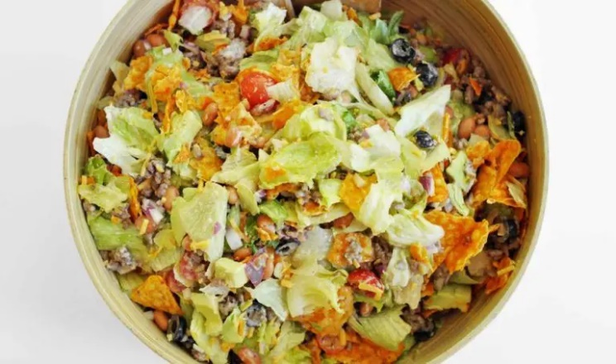
Doritos Taco Salad
Prep Time Cook Time
Servings
Ingredients
1 lb ground beef
¼ cup taco seasoning
1 bag of shredded lettuce
1 large tomato, diced
1 cup shredded cheddar cheese
1 bag (9.75 oz) Doritos
1 cup French or Catalina dressing
1/2 cup sliced olives (optional)
Directions
- Brown the ground beef in a skillet over medium heat. Once thoroughly cooked, drain the excess fat. Stir in the taco seasoning. Let it cool.
- In a large bowl, combine the chopped lettuce, diced tomato, shredded cheese, shredded carrots, and sliced olives.
- Toss in the lightly crushed Doritos into the salad. Keep some for the top as well.
- Add the cooled, seasoned ground beef into the salad mix.
- Lastly, drizzle the French or Catalina dressing all over the salad and give it a good mix, ensuring all the ingredients get coated with the dressing.
- Sprinkle the remaining crushed Doritos on top for an extra crunch.
- Serve immediately to retain the crispiness of the Doritos.
Notes
If you’re preparing ahead of time, keep the Doritos and dressing separate until you’re ready to serve.

